# **final Keyword in Java**

The **final method** in Java is used as a **non-access modifier** applicable only to a **variable**, a **method**, or a **class.** It is used to **restrict a user** in Java**.**

The following are **different contexts** where the final is used:

1. Variable
2. Method
3. Class

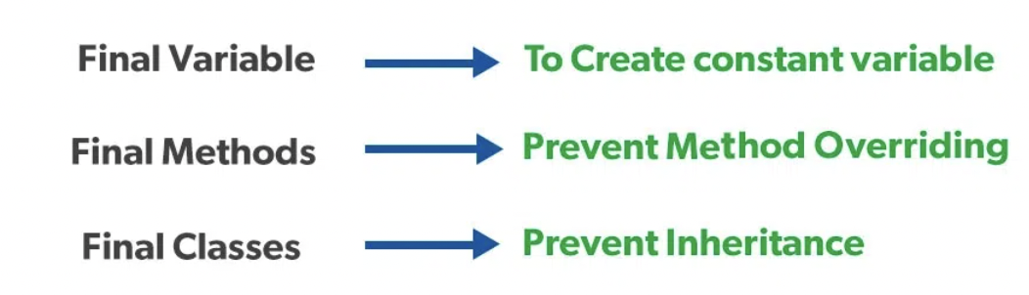

# **this Keyword in Java**

The 'this' keyword in Java can be used to refer to the current class instance variable, invoke the current class method, invoke the current class constructor, and can also be passed as an argument in the method call.

# **super Keyword in Java**

The super keyword refers to superclass (parent) objects. It is used to call superclass methods, and to access the superclass constructor.

## **Use of super keyword in Java**

It is majorly used in the following contexts as mentioned below:

* **Use of super with Variables**
* **Use of super with Methods**
* **Use of super with Constructors**

Super.varaible can be called from any method and in any order

super.method() should be called from overriding method of the child class and in any order - can be first/middle/last

Child class Default constructor will call the parent default constructor implicitly

Child class parameterised constructor will call the parent parameterised constructor explicitly using super() and it should be first statement of the constructor